**Practical 9**

**Principal Component Analysis (PCA)**



**Perform PCA on a dataset to reduce dimensionality.**

**Evaluate the explained variance and select the appropriate number of principal components. Visualize the data in the reduced-dimensional space.**

import matplotlib.pyplot as plt import seaborn as sns

from sklearn.decomposition import PCA

from sklearn.preprocessing import StandardScaler

data = {

'Experience': [1, 3, 5, 7, 9, 11, 13, 15, 17, 19],

'Projects Completed': [1, 2, 4, 5, 7, 8, 10, 12, 14, 16],

'Salary': [30000, 35000, 45000, 50000, 60000, 70000, 80000, 90000, 100000, 120000]

}

df = pd.DataFrame(data) print("\nOriginal Dataset:\n", df.head())

scaler = StandardScaler()

scaled_data = scaler.fit_transform(df)

pca = PCA(n_components=2)

pca_data = pca.fit_transform(scaled_data)

pca_df = pd.DataFrame(pca_data, columns=['PC1', 'PC2']) print("\nPCA Transformed Data:\n", pca_df.head())

explained_variance = pca.explained_variance_ratio_ print("\nExplained Variance Ratio:", explained_variance) print("Total Explained Variance:", sum(explained_variance))

plt.figure(figsize=(6, 4))

plt.bar(range(1, len(explained_variance) + 1), explained_variance, alpha=0.7, color='blue') plt.xlabel('Principal Components')

plt.ylabel('Variance Explained')

plt.title('Explained Variance by Principal Components') plt.show()

plt.figure(figsize=(6, 4))

sns.scatterplot(x=pca_df['PC1'], y=pca_df['PC2'], color='red') plt.xlabel('Principal Component 1')

plt.ylabel('Principal Component 2') plt.title('PCA Visualization') plt.show()

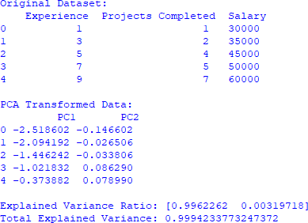

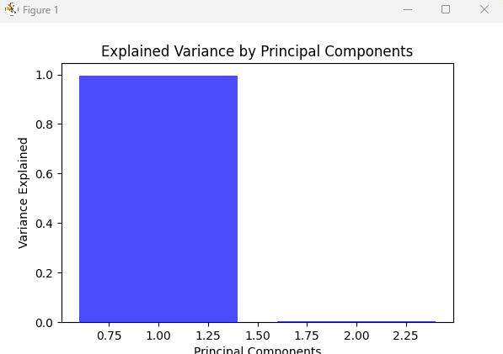

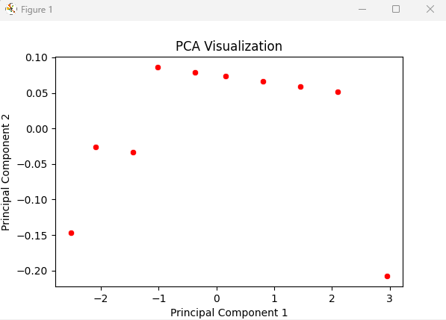

**Conclusion:**

**Dimensionality reduction** was successfully applied, reducing features while maintaining most of the variance.

**Variance ratio** helps to decide how many principal components to retain. **Visualization of PCA components** provides insight into data distribution in a lower- dimensional space.

PCA is an effective tool for handling high-dimensional datasets while preserving critical information.